**Website**

**Campus Life Page**

<!DOCTYPE html>

<html lang="en">

**<head>**

<meta charset="UTF-8">

<title>Campus Life</title>

<link rel="icon" href="images/title-icon.png">

<meta name="viewport" content="width=device-width, initial-scale=1, shrink-to-fit=no">

<link href="https://fonts.googleapis.com/css?family=Open+Sans" rel="stylesheet">

<link href="https://fonts.googleapis.com/css?family=Oswald" rel="stylesheet">

<link href="css/font-awesome.min.css" rel="stylesheet">

<link href="css/bootstrap.css" rel="stylesheet">

<link href="css/slick.css" rel="stylesheet">

<link href="css/venobox.css" rel="stylesheet">

<link href="css/style.css" rel="stylesheet">

<link href="css/responsive.css" rel="stylesheet">

**</head>**

**<body>**

<header>

<!--Menu section Start-->

<div class="navigation">

<div class="navigation_overlay">

<div class="container">

<div class="row p-0 ">

<div class="col-lg-12 col-md-12 p-0 ">

<nav class="navbar navbar-expand-md navbar-light p-0">

<a class="navbar-brand " href="#"><img src="images/logo.png"></a>

<button class="navbar-toggler" type="button" data-toggle="collapse"

data-target="#navbarSupportedContent" aria- controls="navbarSupportedContent"

aria-expanded="false" aria-label="Toggle navigation">

<span class="navbar-toggler-icon"></span>

</button>

<div class="collapse navbar-collapse" id="navbarSupportedContent">

<ul class="navbar-nav ml-auto">

<li class="nav-item">

<a class="nav-link " href="index.html">Home </a>

</li>

<li class="nav-item">

<a class="nav-link" href="about.html">About </a>

</li>

<li class="nav-item">

<a class="nav-link" href="academic-career.html">Academic Career</a>

</li>

<li class="nav-item">

<a class="nav-link" href="fnf.html">FnF</a>

</li>

<li class="nav-item">

<a class="nav-link active" href="#">Campus Life</a>

</li>

<li class="nav-item">

<a class="nav-link " href="career-plan.html">Career Plan</a>

</li>

</ul>

</div>

</nav>

</div>

</div>

</div>

</div>

</div>

<!--Menu section Start-->

<div class="banner">

<div id="carouselExampleIndicators" class="carousel slide" data-ride="carousel">

<ol class="carousel-indicators">

<li data-target="#carouselExampleIndicators" data-slide-to="0" class="active"></li>

<li data-target="#carouselExampleIndicators" data-slide-to="1"></li>

<li data-target="#carouselExampleIndicators" data-slide-to="2"></li>

</ol>

<div class="carousel-inner">

<div class="carousel-item active text-center">

<img class="d-block w-100" src="images/banner-1.jpg" alt="First slide">

<div class="overlay_one">

<div class="container">

<div class="text">

<h3>Hi, My name is </h3>

<h1>Afifa Nowshin Joya</h1>

<p>I Am A Student. I Studies Bsc In Computer Science & Engineering At Stamford University.I Want To Be A Good Quality Web Developer</p>

<a href="" class="active">join now</a>

<a href="">views more</a>

</div>

</div>

</div>

</div>

<div class="carousel-item">

<img class="d-block w-100" src="images/banner-2.jpg" alt="Second slide">

<div class="overlay_one">

<div class="container">

<div class="text">

<h3>hi, my name is </h3>

<h1>Afifa Nowshin Joya</h1>

<p>I Am A Student. I Studies Bsc In Computer Science & Engineering At Stamford

University.I Want To Be A Good Quality Web Developer</p>

<a href="" class="active">join now</a>

<a href="">views more</a>

</div>

</div>

</div>

</div>

<div class="carousel-item">

<img class="d-block w-100" src="images/banner-3.jpg" alt="Third slide">

<div class="overlay_one">

<div class="container">

<div class="text">

<h3>Hi, my name is </h3>

<h1>Afifa Nowshin Joya</h1>

<p>I Am A Student. I Studies Bsc In Computer Science & Engineering At Stamford

University.I Want To Be A Good Quality Web Developer</p>

<a href="" class="active">join now</a>

<a href="">views more</a>

</div>

</div>

</div>

</div>

</div>

</div>

</header>

<!--Campus Life Section Start -->

<section id="campus-life">

<div class="container">

<div class="row">

<div class="col-lg-12 col-md-12 col-sm-12">

<div class="campus-life-top text-center">

<h2 class="pt-5">Campus Life </h2>

<img src="images/d-icon.png">

<h4 class="cl-header py-5">Campus Life knows that adolescence can be the best of times and the

worst of times, and it is always a pivotal time in a young person's life.</h4>

</div>

</div>

<div class="col-md-4 py-5">

<div class="about-campus-life">

<h5 class="acl-title">What Is Campus Life?</h5>

<p class="acl-text">Campus Life is a program of Youth For Christ, a non-profit organization that

has been active throughout the United States for over 65 years. Currently Campus Life has

over 1,000 sites located throughout 40 states. Along with fantastic trips and events, our

weekly meetings address issues students face while relating them to basic Christian

principles.</p>

</div>

</div>

<div class="col-md-4 py-5">

<div class="about-campus-life">

<h5 class="acl-title">Who can come?</h5>

<p class="acl-text">Campus Life isn't just for one kind of kid, it is for everyone. It is open

to every student regardless of their race, gender, religious beliefs, or economic

circumstances. We would encourage you to speak to your local Campus Life director to learn

more about the specific program offered in your area..</p>

</div>

</div>

<div class="col-md-4 py-5">

<div class="about-campus-life">

<h5 class="acl-title">How is Campus Life funded?</h5>

<p class="acl-text">Campus Life is supported through the generous donations of our community

partners. They enable us to offer the majority of our programming at no cost to the student

or their family.</p>

</div>

</div>

<div class="col-md-4 ">

<div class="about-campus-life">

<h5 class="acl-title">What is Campus Life like?</h5>

<p class="acl-text">Campus Life is a positive place where students can go to have fun with

friends, talk about relevant issues and be heard without judgment. It’s a place where

students are challenged to make good decisions and lead in positive ways in their school. In

addition to weekly club meetings, CL offers trips, small groups and other activities.</p>

</div>

</div>

<div class="col-md-4 ">

<div class="about-campus-life">

<h5 class="acl-title">Is it safe?</h5>

<p class="acl-text">Campus Life is a safe environment. All staff and volunteers are carefully

screened and have gone through an extensive application process which includes references, a

face-to-face interview and a professional background check.</p>

</div>

</div>

<div class="col-md-4 ">

<div class="about-campus-life">

<h5 class="acl-title">Individually Focused </h5>

<p class="acl-text">Campus Life knows the journey of adolescence is different for everyone. We

are committed to coming alongside students, meeting them where they are, in order to help

them navigate these years..</p>

</div>

</div>

<div class="col-md-4 py-5">

<div class="about-campus-life">

<h5 class="acl-title">Relationally Based </h5>

<p class="acl-text">Campus Life has found the importance of shared experiences between a student

and caring supportive adult are indispensable. This is why we place the primary focus on

relationships and not programs.</p>

</div>

</div>

<div class="col-md-4 py-5">

<div class="about-campus-life">

<h5 class="acl-title">How much does it cost?</h5>

<p class="acl-text">Cost are different for different campuses.It is not specific.In our country,

there is not much cost in public University. There are variations of costs in private

universities</p>

</div>

</div>

<div class="col-md-4 py-5">

<div class="about-campus-life">

<h5 class="acl-title">My Campus ?</h5>

<p class="acl-text">I am Afifa Nowshin Joya. I Studies in Computer Science & Engineering at

Stamford University Bangladesh. <strong><a href="myCampus.html" class="mycampus"

target="_blank">Click here</a></strong> to See Our Campus</p>

</div>

</div>

</div>

</div>

</section>

<!--Footer Section Start-->

<section id="footer_design">

<div class="footer">

<div class="footer_overlay">

<div class="container">

<div class="row p-0">

<div class="col-lg-12 col-md-12 col-sm-12 text-center p-0">

<h2><img src="images/logo.png"></h2>

</div>

<div class="col-lg-1 col-md-1 p-0">

<ul>

<li>

<h5>Working Days

</h5>

</li>

<li>

<p>Saturday</p>

</li>

<li>

<p>Sunday</p>

</li>

<li>

<p>Monday</p>

</li>

<li>

<p>Tuesday</p>

</li>

<li>

<p>Wednessday</p>

</li>

<li>

<p>Thursday</p>

</li>

<li>

<p>Friday</p>

</li>

</ul>

</div>

<div class="middle" class="col-lg-2 col-md-2 pr-0">

<ul>

<li class="pb-1">

<p>08:00 A.M. - 6:00 P.M.</p>

</li>

<li class="pb-1">

<p>08:00 A.M. - 6:00 P.M.</p>

</li>

<li class="pb-1">

<p>08:00 A.M. - 6:00 P.M.</p>

</li>

<li class="pb-1">

<p>08:00 A.M. - 6:00 P.M.</p>

</li>

<li class="pb-1">

<p>08:00 A.M. - 6:00 P.M.</p>

</li>

<li class="pb-2">

<p>08:00 A.M. - 6:00 P.M.</p>

</li>

<li>

<p>Holiday</p>

</li>

</ul>

</div>

<div class="col-lg-3 col-md-3 pr-0">

<h5>Twetter Feed</h5>

<h4><i class="fa fa-twitter" aria-hidden="true"></i>We want to introduce you to a new web

theme

. This the new idea for application, hope you will

like.<br> 10 Jan 2020</h4>

<h6><i class="fa fa-twitter" aria-hidden="true"></i>We want to introduce you to a new web

theme

theme portfolio persue new press theme. <br> 10 Jan 2020 </h6>

</div>

<div class="col-lg-3 col-md-3 pl-0">

<h5>Flicker Photos</h5>

<img src="images/footer-1.jpg">

<img src="images/footer-2.jpg">

<img src="images/footer-3.jpg">

<img src="images/footer-3.jpg">

<img src="images/footer-2.jpg">

<img src="images/footer-1.jpg">

<img src="images/footer-3.jpg">

<img src="images/footer-2.jpg">

<img src="images/footer-1.jpg">

</div>

<div class="col-lg-3 col-md-3 p-0">

<ul>

<li>

<h5>Contact</h5>

</li>

<li>

<h3><i class="fa fa-map-marker" aria-hidden="true"></i> Malibagh, Mouchak Dhaka 1219

</h3>

</li>

<li>

<h3>

<i class="fa fa-phone" aria-hidden="true"></i>

+88 01775759452

</h3>

</li>

<li>

<h3><i class="fa fa-envelope-open-o" aria-hidden="true"></i>

afifanowshinjoya@gmail.com</h3>

</li>

<li>

<h3> <span>get Social</span></h3>

</li>

<li> <a href="#">f</a></li>

<li> <a href="#">f</a></li>

<li> <a href="#">f</a></li>

<li> <a href="#">f</a></li>

</ul>

</div>

<div class="col-lg-12 text-center pb-3 ">

<h1>Copyright  All rights reserved by <span>Afifa</span></h1>

</div>

</div>

</div>

</div>

</div>

</section>

</section>

<!-- All Javascript Link Here-->

<script src="js/jquery-1.12.4.min.js"></script>

<script src="js/bootstrap.min.js"></script>

<script src="js/slick.min.js"></script>

<script src="js//venobox.min.js"></script>

<script src="js//jquery.counterup.min.js"></script>

<script src="js/waypoints.min.js"></script>

<script src="js/custom.js"></script>

**</body>**

</html>

**CSS Code Here…**

.navigation {

    position: absolute;

    top: 30px;

    left: 0;

    z-index: 99999;

    width: 100%;

}

Header .navfixed {

    position: fixed;

    width: 100%;

    background: #cc0000;

    top: 0;

    left: 0;

    z-index: 999999;

}

.navigation_overlay {

    background: rgba(53, 53, 53, 0.2);

}

Header .navigation nav .nav-item .nav-link {

    text-transform: uppercase;

    color: #f1f1f1;

    text-align: center;

    font-family: 'Oswald', sans-serif;

    font-weight: 400;

    font-size: 14px;

    margin: 0 7px;

    padding: 0 4px;

    line-height: 50px;

}

Header .navigation nav .nav-item .nav-link:hover {

    background: #ffffff;

    border-bottom: 3px solid #e23e38;

}

Header .navigation nav .nav-item .nav-link.active {

    background: #ffffff;

    border-bottom: 3px solid #e23e38;

}

Header .navbar-brand {

    background: #313131;

    transform: skew(-16deg);

    padding: 15px 30px;

}

Header .navbar-brand img {

    transform: skew(16deg);

}

Header {}

Header .overlay_one {

    position: absolute;

    width: 100%;

    height: 100%;

    background: rgba(53, 53, 53, 0.25);

    top: 0;

    left: 0;

}

Header .overlay_one .text h3 {

    color: #ffffff;

    font-family: 'Oswald', sans-serif;

    font-weight: 400;

    font-variant: small-caps;

    font-size: 30px;

    padding-top: 100px;

}

Header .overlay_one .text h1 {

    color: #e23e38;

    font-family: 'Oswald', sans-serif;

    font-weight: 400;

    font-size: 60px;

    padding-top: 20px;

    text-transform: uppercase;

}

Header .overlay_one .text p {

    color: #f7f7f7;

    font-size: 14px;

    padding-top: 20px;

    text-transform: capitalize;

}

Header .overlay_one .text a {

    border: 1px solid #f1f1f1;

    display: inline-block;

    line-height: 36px;

    margin-left: 15px;

    margin-right: 15px;

    padding: 0 20px;

    color: #ffffff;

    text-transform: uppercase;

    font-family: 'Oswald', sans-serif;

    font-weight: 500;

    font-size: 16px;

    margin-top: 40px;

}

Header .overlay_one .text a.active {

    background: #e23e38;

}

Header .overlay_one .text a:hover {

    background: #ffffff;

    transition: all linear 0.4s;

    color: #e23e38;

}

.carousel-indicators li {

    width: 15px;

    height: 15px;

    border-radius: 50%;

    border: 1px solid #fff;

    background: none;

    cursor: pointer;

}

.carousel-indicators li.active {

    background: #cc0000;

}

/*****  Header Section ends   ****/

/*****   Campus Life Section Start   ******/

#campus-life {

    background-color: #FAFAFA;

}

.cl-header {

    color: #666666;

}

.about-campus-life {

    padding: 15px 20px;

}

.about-campus-life:hover {

    background-color: #1da1f2;

    transition-duration: 0.5s;

    border-top-right-radius: 25px;

}

.acl-title {

    padding-bottom: 20px;

    font-weight: bold;

}

.acl-text {

    text-align: justify;

}

.mycampus {

    color: red;

    text-decoration: none;

}

.mycampus:hover {

    color: white;

}

/*****    Footer Section Start    ******/

.footer {

    background: url(../images/banner-1.jpg) no-repeat center;

    background-size: cover;

    position: relative;

    height: 100%;

}

#footer_design .footer h5 {

    font-family: 'Oswald', sans-serif;

    font-weight: 400;

    font-size: 14px;

    text-transform: uppercase;

    color: #ffffff;

    padding-top: 60px;

    padding-bottom: 27px;

}

#footer_design .footer .middle {

    font-family: 'Open Sans', sans-serif;

    font-weight: 400;

    font-size: 13px;

    text-transform: capitalize;

    color: #ffffff;

    padding-top: 110px;

}

.footer h5 {

    color: #fff;

}

.footer h4 {

    color: #fff;

    font-family: 'Open Sans', sans-serif;

    font-weight: 400;

    font-size: 13px;

    text-transform: capitalize;

    padding-top: 10px;

    margin-right: 25px;

}

.footer h4 i {

    color: #1da1f2;

}

.footer h6 {

    color: #fff;

    font-family: 'Open Sans', sans-serif;

    font-weight: 400;

    font-size: 13px;

    text-transform: capitalize;

    padding-top: 9px;

    margin-right: 25px;

    margin-top: 10px;

}

.footer h6 i {

    color: #1da1f2;

}

.footer h3 {

    color: #f1f1f1;

    font-family: 'Open Sans', sans-serif;

    font-weight: 400;

    font-size: 13px;

    text-transform: capitalize;

    padding: 10px 0;

}

.footer h3 i {

    color: #ce3833;

}

h3 span {

    font-size: 16px;

    font-family: 'Open Sans', sans-serif;

    font-weight: 400;

    text-transform: uppercase;

}

.footer h1 {

    font-family: 'Open Sans', sans-serif;

    font-weight: 400;

    font-size: 13px;

    padding-top: 50px;

    text-transform: uppercase;

    color: #fff;

}

.footer h1 span {

    color: #ce3833;

}

.footer p {

    color: #fff;

}

.footer ul li a {

    float: left;

    color: #fff;

    padding: 0 10px;

    border: 2px solid #ffffff;

    margin: 0 3px;

}

.footer .footer_overlay {

    background: rgba(0, 0, 0, 0.85)

}

.footer .footer_overlay h2 {

    padding-top: 34px;

}

.footer ul li a:hover {

    background: #fff;

    transition: all linear 0.4s;

    color: #000;

}

/**** Footer Section End ****/

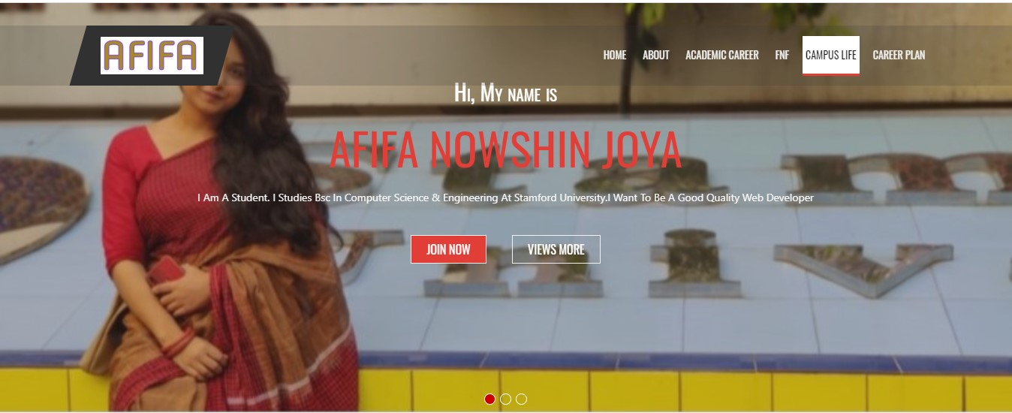

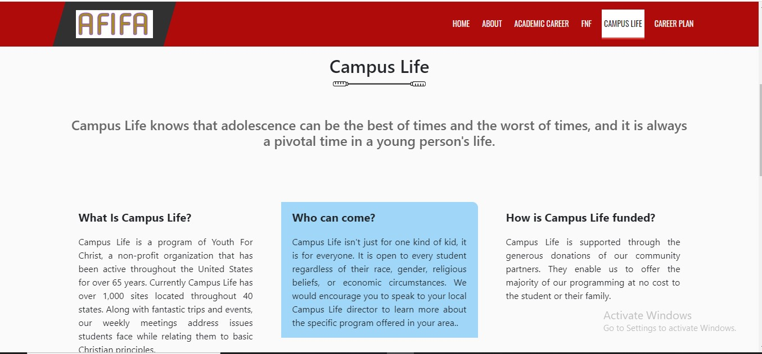

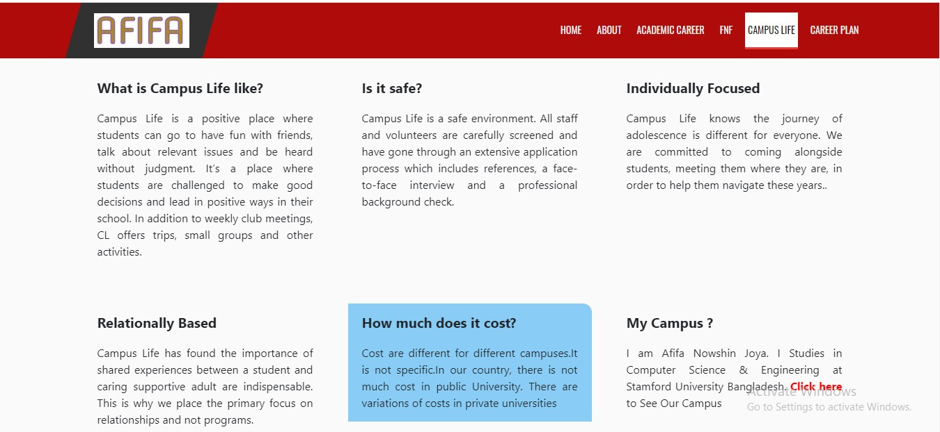



**Click here then this page …..**

